Programming Exercise 1: Linear Regression

Machine Learning

Student Name: Ethan Hitchcock

PeopleSoft ID: 1408202

Question (1)

Please plot the figure of Training data with linear regression fit below:

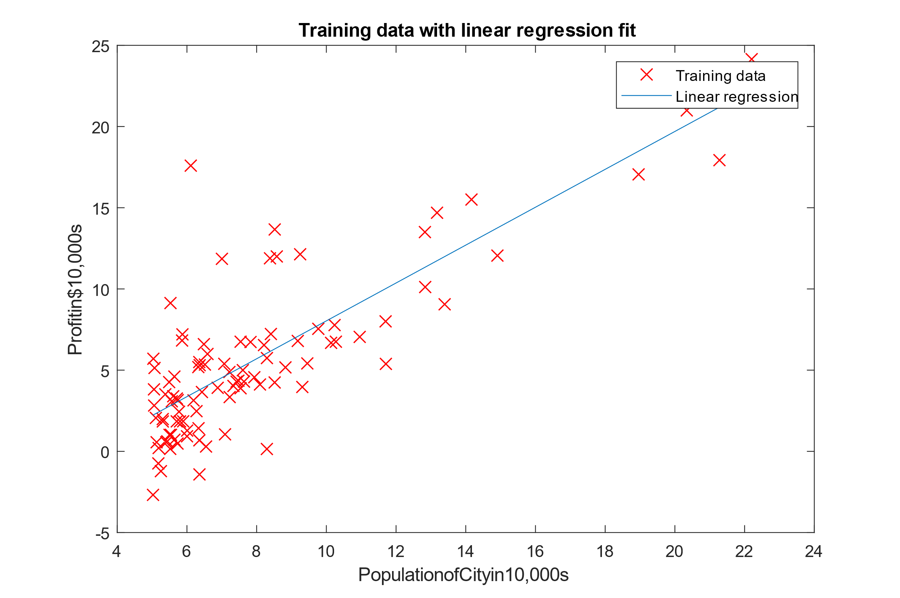

Question (2)

Please give the value of initial cost J when theta are all zeros:

J = $32.072734

Question (3)

Please give the Prediction on profits in areas of 45,000 people:

Profits = $16183.391371

Question (4) (optional)

Minimum cost J and values of theta when theta is **not** updated simultaneously:

J = $4.483112

Theta = [-3.636063 ; 1.166989]